KH6RS Beacon Install Report

# Summary

A new beacon was installed on January 10, 2016 at the QTH of NH6Y, Tom Worthington. The callsign is KH6RS, the club callsign of the Maui Amateur Radio Club ([www.KH6RS.org](http://www.KH6RS.org)).

This is all V2 hardware, using the newly designed controller and an ICOM IC-7200.

Status – the beacon has been operational since initial install and has continued to function. Various reports have been received.

## Issues

1. TX power for the lowest setting (100mW) still doesn’t seem close to the correct level.
2. Callsign change is still propagating.
3. Potential Interference to NH6Ys station.

# Acknowledgements & Thanks

Getting the KH6RS beacon on the air took a team of Hams.

* NH6Y – took on the project, money, and time into it, rallied the KH6RS club around it. Didn’t give up when the project took four months longer than it should.
* KH6RS – Maui Amateur Radio Club – for support and sponsorship, including K6GSS.
* AD6E – taking on getting the HI beacon re-sited, and also not giving up when things too longer than expected.
* N6TV – various technical contributions including working on power level problem, and getting RBN watch list updated.
* AB6WM/VE3SUN – coordinating the IBP forever, and tons of hugely helpful direction and advise.
* Large number of Ham that worked to get V2 working, especially - N9JA, K6GSJ, K6TU, WA6ZNU, ND2T, KA6W, K6UM.
* Lastly, but by no means least, the XYLs of K6TD, AD6E, and NH6Y for accommodating this endeavor.

# Details

## Description of installation

The V2 hardware consists of a newly developed controller, and ICOM IC-7200 radio and a Timing style GPS antenna. The installation site supplied the power supply and the Cushcraft MA5V antenna. The controller is running V2.5 of the software.

The hardware was transported by K6TD to Maui in a Pelican case as checked luggage on January 9th.

The location is in the rear of the garage of the QTH of Tom, NH6Y, mounted on a shelf about five feet high. The antenna is mounted about 15 feet off the ground a short distance from the garage. The GPS antenna is mounted at the peak of the garage roof. Hazards to the location are “critters and ants”. Tom will construct an enclosure to protect. The AC power is from the local power company, and has a good track record for up time. Tom indicates he will monitor the up time, and if needed, supply power to the unit via a battery and Solar panel.

Upon first power up, the unit quickly found GPS lock and began beaconing in slot 30 seconds. Various monitoring reports said “it sounds good”.

N6TV has put out notes to get the reverse beacon listen list updated and contacted W3OA to get the RBN aggregator updated. Dick is on K5P, so RBN won’t get updated till around the end of the January 2016.

Peter, AB6WM/VE3SUN has uploaded a new version of the Beacons.lst file for FAROS to the NCDXF web site. Alex, VE3VNEA has issued an update to the FAROS program to incorporate the changes to beacon QTHs. Note: N6TV found a few other errors in this file, due to other beacon moves. Those changes have also been incorporated to the updates.

<http://dxatlas.com/Faros/Files/Faros.zip>

<http://dxatlas.com/Faros/Files/BeaconList.zip>

<http://www.ncdxf.org/beacon/programs/Beacon.lst>

Tom, NH6Y gave me a Codan brand HF radio that he’d like to make work with the beacon controller. It’s a great HF radio, recent, and just sitting at Tom’s QTH. I brought it back to Cupertino, and will work on integrating for Tom. When done and tested, I’ll send to Tom for a swap of the IC-7200.

## Issues

**100mW power level.** N6TV first reported the W6WX beacon seemed to have the same signal strength at his QTH for both 1W and 100mW. Testing with a power meter seemed to show this to be the case. Testing and trying various solutions hasn’t gotten the power level of 100mW. We continue to work on this problem.

No new V2 controllers will be deployed till this problem is solved.

**Callsign change.** It’s very rare that a beacon callsign would change. This being the first one in a long time (perhaps ever), we learned all the issues and items that need to be updated. It’s not impossible, but, doesn’t take some time.

**Interference to NH6Y.** Tom maintains a very active station and is an avid HF DX’er and contestor. The antenna for the beacon is within 200 yards of this main upper band antenna – a Steppir 4 element Yagi. Testing so far says no interference out of band. In band, there seems to be slight interference. AD6E will take his K3 to see if the interference is still heard. Tom will continue to monitor.

## History

The Hawaii beacon was originally on Oahu, as KH6WO, Honolulu Amateur Radio club. In May of 2015, Larry LeMone, the maintainer of the beacon equipment indicated he’d no longer be able to perform those duties, as he was moving to the Nevada. At that time, the beacon was off the air, due to equipment failures.

Tom, ND2T, president of NCDXF put out a call for help. AD6E, now living on Maui, arranged to have the beacon installed at the home QTH of NH6Y. After discussion, it was decided to push forward with this site and use the new V2 beacon software. Because the old site used the Oahu club callsign, the decision was made to use the callsign of the Maui Radio club – KH6RS.

# Photos of Installation

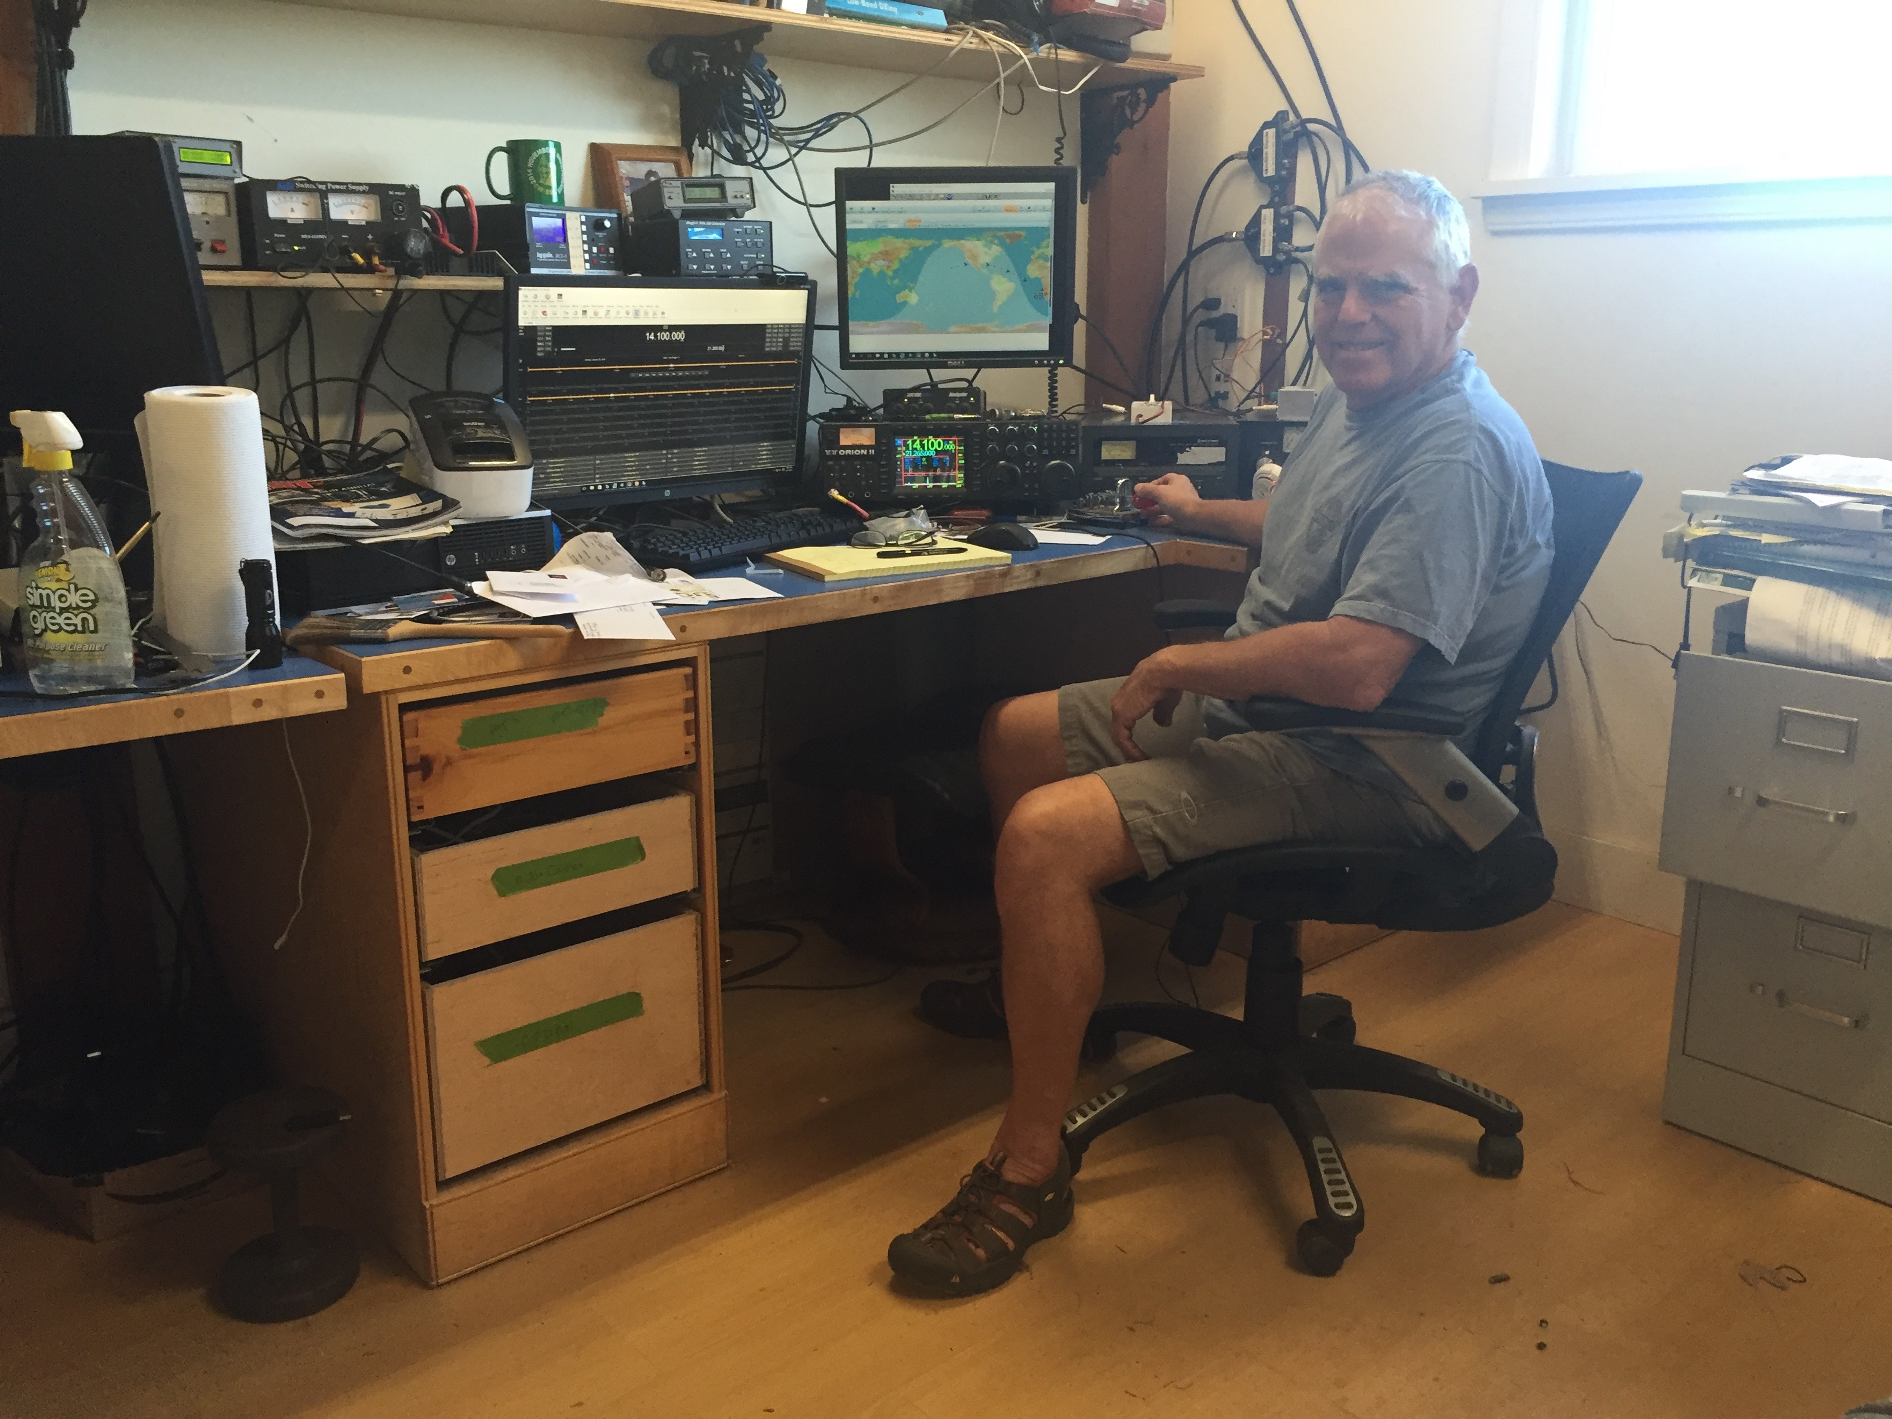

NH6Y in his Shack

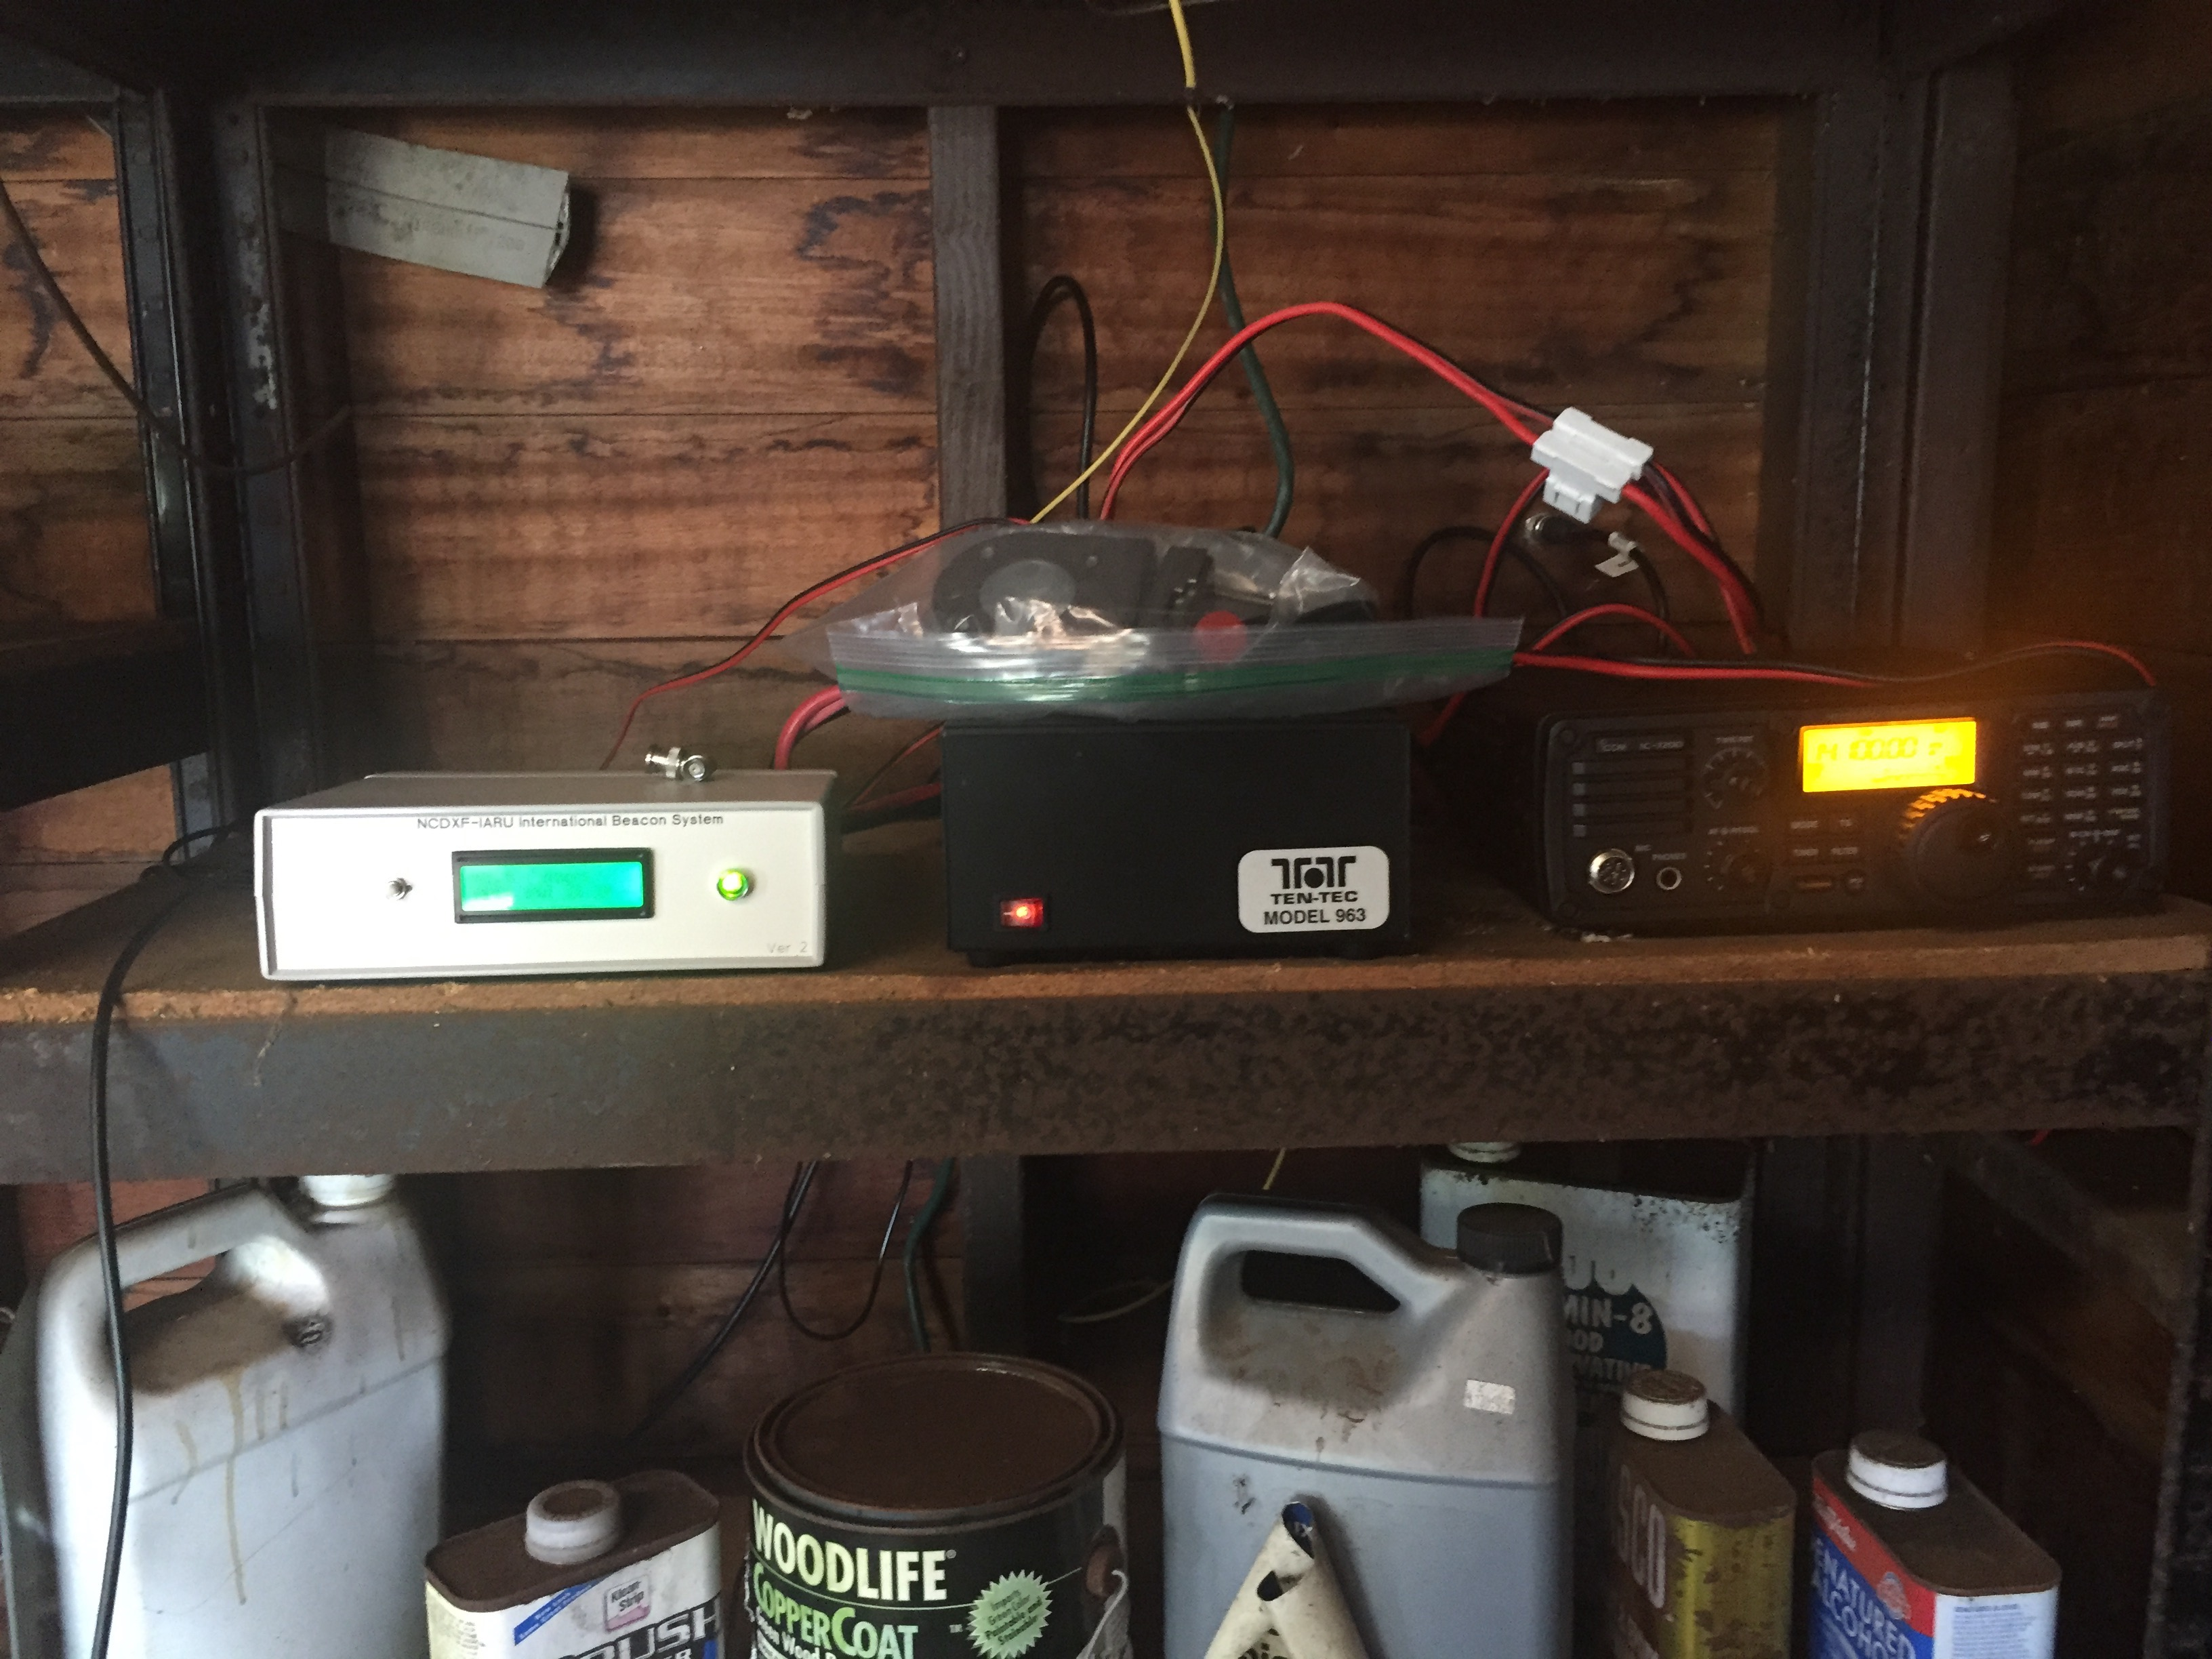

KH6RS - garage NH6Y

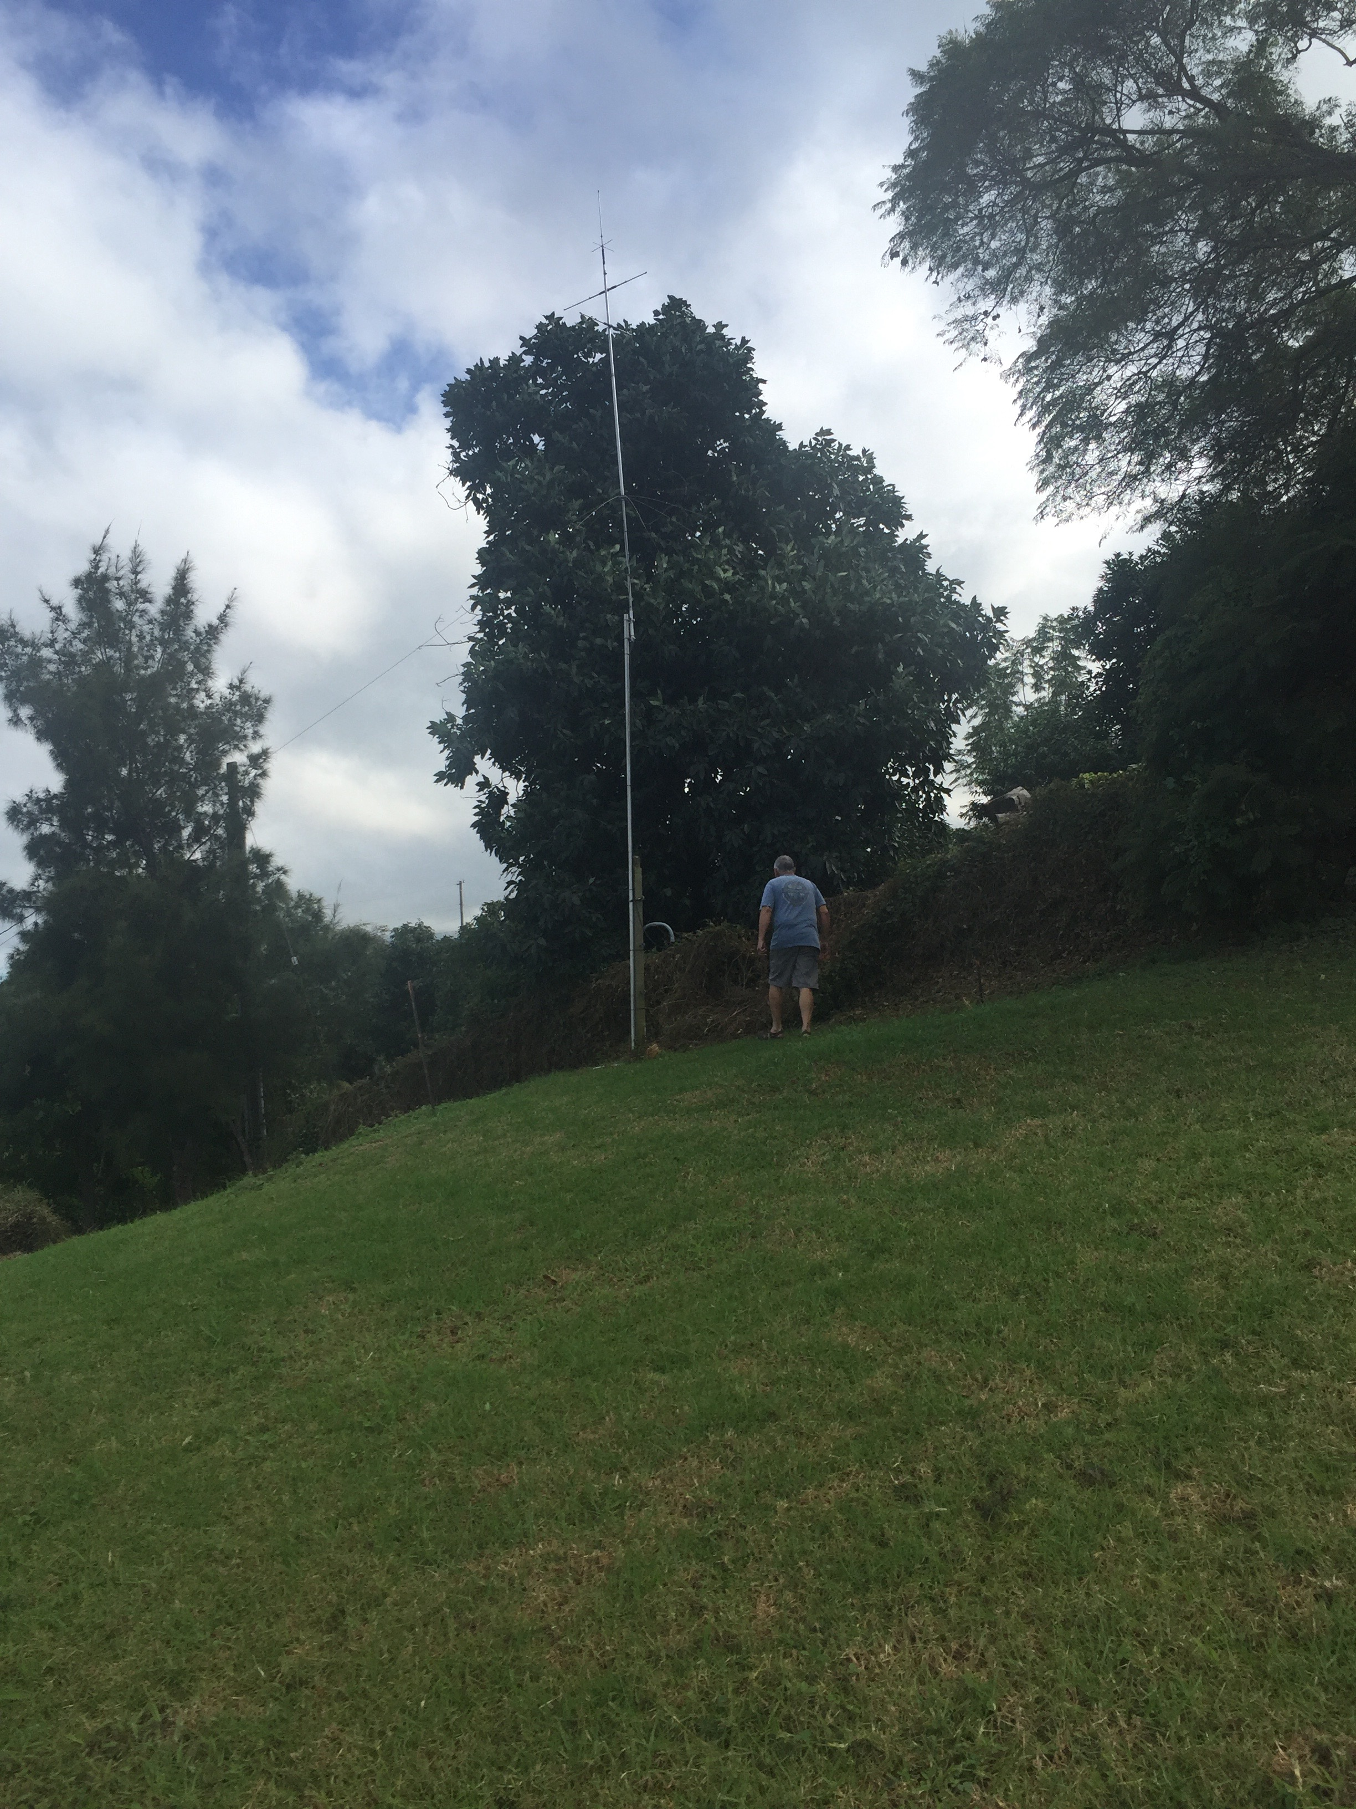

Antenna and Tom

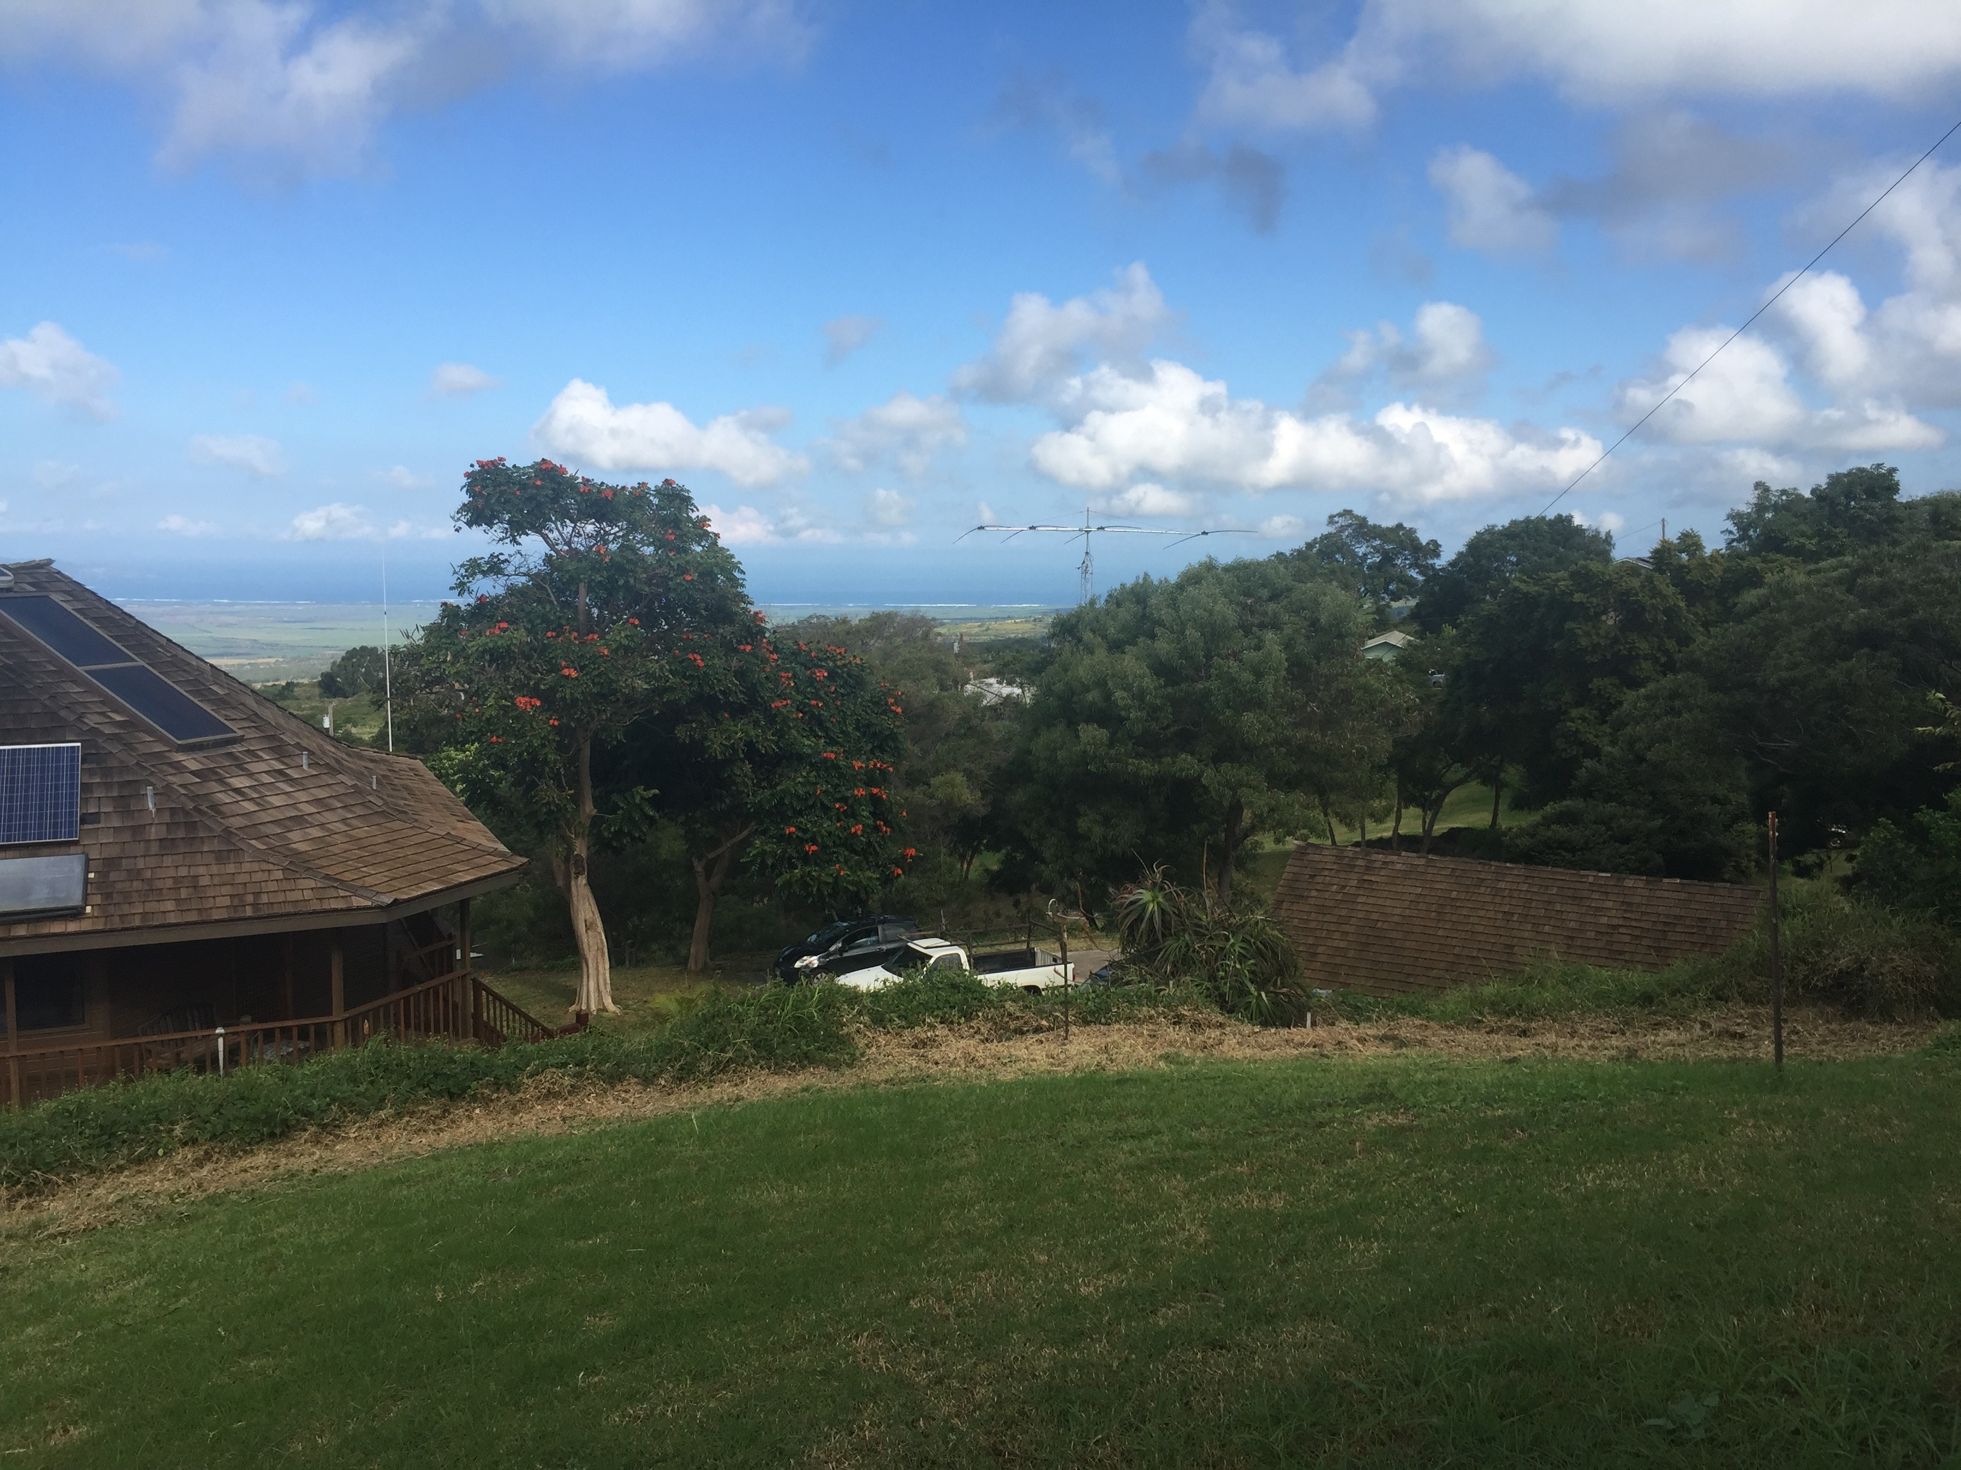

Looking NW from antenna

# Addendums

## Note from Larry LeMone

**From:** Larry LeMone [<mailto:llemone@hawaii.rr.com>]  **Sent:** Friday, July 24, 2015 12:58 PM **To:** Charlie Mason **Cc:** 'Tom Berson'; Steve Lund **Subject:** KH6WO Hawaiian Beacon

Charlie,

As you are aware, KH6WO beacon here in Hawaii has been ‘off the air’ for some time.  The equipment – controller, TS-50 and power supply are all very old.  In fact, the Astron power supply quit some years ago and was replaced by another supply from my personal supply of equipment.

As of now, I don’t see that the TS-50 will be repaired or replaced  … at least in the near future.  Incidentally, the GPS antenna and HF antenna are also ‘feeling their age’.

I am in somewhat an awkward position in that in the next few months I will be moving to the State of Nevada.  Living no longer in Hawaii, I will no longer be able to take care of NCDXF beacon equipment.

In addition to me leaving the State of Hawaii, KH6WO(licensed to Hawaii Amateur Radio Club)…. is pretty much an ‘at large club’ ….. I think that John Peters(K1ER) was or is the current president.  His email address is:    [petersj007@hawaii.rr.com](mailto:petersj007@hawaii.rr.com)    John might be able to help you locate a new operator and location when the beacon is restored here in Hawaii.

I’m not sure what to do with the current equipment.   Unless I hear differently from you, I will donate the useable equipment to a local group of hams that are on this island.

It’s been my pleasure and enjoyment to take care of the NCDXF beacon here in Hawaii for over 15 years.  I have really loved it and hope that the new beacon system can be established once again here in the Aloha State.

73’s,

Larry

## Latest beacon.lst file for FAROS

This is for reference only. If you need to use this file, get it from the URL above.

02|-13314|7335|4U1UN

02|-15471|14397|VE8AT

02|-21942|6687|W6WX

02|-28141|3736|KH6RS

02|31608|-7389|ZL6B

02|20889|-5778|VK6RBP

02|24621|6201|JA2IGY

02|14922|9897|RR9O

02|20547|4008|VR2B

02|14439|1098|4S7B

02|5088|-4662|ZS6DN

02|6669|-183|5Z4B

02|6258|5769|4X6TU

02|4470|10857|OH2B

02|-3024|5889|CS3B

02|-10503|-6231|LU4AA

02|-13851|-2172|OA4B

02|-12033|1875|YV5B

## RBN update to watch list – N6TV

For reference only!

The operators of the [NCDXF Beacon Network](http://www.ncdxf.org/pages/beacons.html) could use our help to generate automatic spots for the new beacon station, KH6RS, which replaces KH6WO.

To help CW Skimmer and Skimmer server spot this new beacon, please update (or create) a text file named:

%appdata%\Afreet\UserData\Watch.lst

with one line per call:

4U1UN

VE8AT

W6WX

KH6RS

ZL6B

VK6RBP

JA2IGY

RR9O

VR2B

4S7B

ZS6DN

5Z4B

4X6TU

OH2B

CS3B

LU4AA

OA4B

YV5B

Note: %appdata% is a Windows standard environment variable that automatically expands to C:\Users*UserName*\AppData\Roaming.  You can use "%appdata%" in any Windows dialog or on the Windows command line.

If necessary, adjust the CWSegments in your SkimSrv.ini file to include the beacon frequencies (14.100, 18.110, 21.150, 24.930, and 28.200).

Details are outlined in two RBN blog posts by N4ZR, here:

<http://reversebeacon.blogspot.com/search?q=ncdxf>

Look for the .ini files here:

%appdata%\Afreet\Products\SkimSrv\SkimSrv.ini

%appdata%\Afreet\Products\CwSkimmer\CwSkimmer.ini

The NCDXF relies on the Reverse Beacon Network on a daily basis to automatically check beacon status and look for problems, so our Skimmer spots are very much used and appreciated.

73,

Bob, N6TV

From: **Pete Smith N4ZR** [**n4zr@contesting.com**](mailto:n4zr@contesting.com) **[RBN-OPS]**

Date: Tue, Jan 12, 2016 at 9:16 AM

Subject: Re: [RBN-OPS] Re: Please update Watch.lst to spot new NCDXF beacon KH6RS, replacing KH6WO

To: [RBN-OPS@yahoogroups.com](mailto:RBN-OPS@yahoogroups.com)

Yes, it's a double-whammy.  First you make the Skimmer Server .ini changes outlined in the Aggregator 4 user manual.  KH6RS will then be spotted by Skimmer Server and passed on to the Aggregator. At that point Aggregator has to know to circumvent its rule of only posting CQ spots to the mother ship, and that's where the files Bob spotted come in.  Dick, W3OA, the author of the Aggregator, is on his way to Palmyra right now, so this will have to await his return

73, Pete N4ZR

Download the new N1MM Logger+ at

[<http://N1MM.hamdocs.com>](http://n1mm.hamdocs.com/). Check

out the Reverse Beacon Network at

[<http://reversebeacon.net>](http://reversebeacon.net/), now

spotting RTTY activity worldwide.

For spots, please use your favorite

"retail" DX cluster.

Spot for KH6RS

